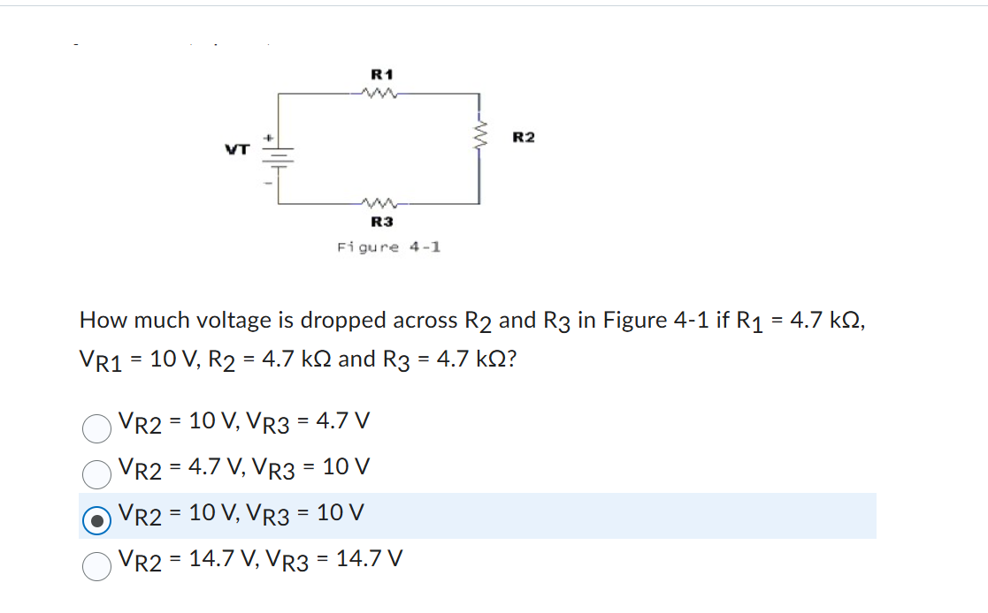
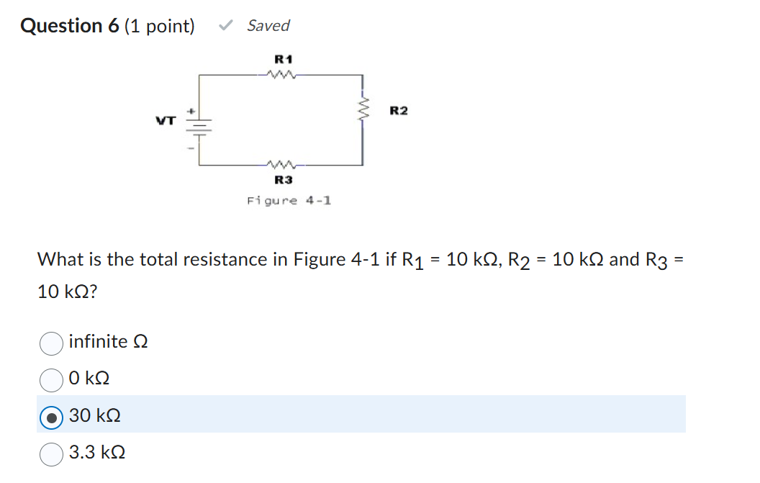
Question 2 (1 point)

Saved
When the resistance and voltage are known, what is the formula for finding the current (amperes)?
Question 2 options:
I = R/V
I = V/R
I = V x R
I = V x R
Question 3 (1 point)

Saved
When a 24-volt battery is connected to a series circuit with three resistors of 1 ohm, 3 ohms, and 2 ohms, how many amperes of current will flow through the circuit?
Question 3 options:
1
3
4
2
Question 4 (1 point)

Saved
A 4.7 kΩ resistor has 3 mA of current passing through it. The resistor dissipates
Question 4 options:
42.3 W
35.2 mW
42.3 mW
14.1 mW
Question 5 (1 point)

Saved
The sum of the voltage drops in a series circuit equals the:
Question 5 options:
Source voltage
Total resistance
Current in circuit
Resistance in branch

milli (m) means which of these?
Question 7 options:
1
10⁰
10³
10⁻³
Question 8 (1 point)

Saved
The formula for total resistance (RT) in a series circuit is which of these?
Question 8 options:
R_{T} = R₁ - R₂
R_{T} = R₁ X R₂ X R₃
R_{T} =
R_{T} = R₁ + R₂ + R₃
Question 9 (1 point)

Saved
kilo (k) means which of these?
Question 9 options:
10³
10⁻³
10⁰
1
Question 10 (1 point)

Saved
A series circuit consists of three resistors with values of 1.1 kΩ, 4.4 kΩ, and 2.5 kΩ across a 30 V source. The current through the 2.5 kΩ resistor is
Question 10 options:
2.24 μA
3.75 mA
3.75 A
2.24 mA

